# QualDash 2.0 Release Notes

06.01.2020

Contents

QualDash 2.0 Release Notes 1

Introduction 1

What’s new in QualDash 2.0 1

Non audit-specific 1

Picanet-specific 3

MINAP-specific 4

## Introduction

The QualDash project is designing and evaluating an interactive dashboard to improve quality of care. This document contains the release notes for QualDash version 2.0, which has been enhanced from version 1.0 (***release date: 06.01.2020***) following feedback from five NHS Trusts. The project is funded by the National Institute for Health Research (NIHR) Health Services & Delivery Research (HS&DR) Programme (project number 16/04/06).

## What’s new in QualDash 2.0

### Non audit-specific

* Card information, including the last recorded event for a specific metric, is displayed upon hovering the mouse on the card title.

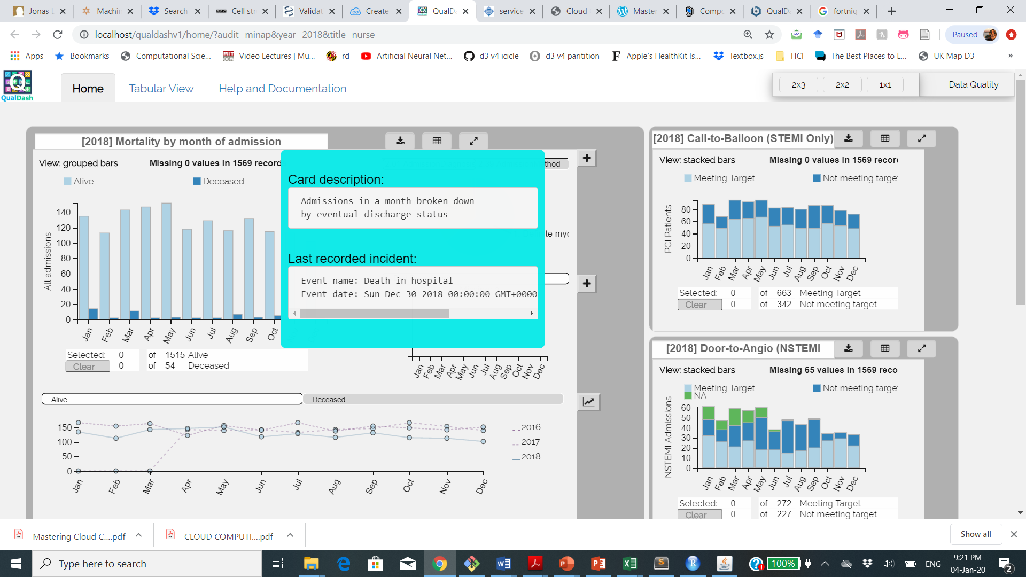

* The history sub-view has an improved color scheme: the point colour matches the colour of the corresponding bars in the main view for the variable shown in the history sub-view.
* The history sub-view also an improved pattern: the solid line always represents data for the year which is currently loaded in the dashboard. All historic data (i.e. previous years) are shown as dashed lines with varying patterns.
* The aggregation rule used in the quantities sub-view is moved from the axis label (which was cluttered by the ticks on the y-axis previously) to the header of the tab that contains the view. The example in the figure shows the word “(aggregate)” appended to the name of the variable to reveal what is shown in the view.
* **Bug fix:** The save button used to include a black area when saving visualizations that include line charts. This is now fixed. An example is shown below for a PMG file saved before and after the fix.

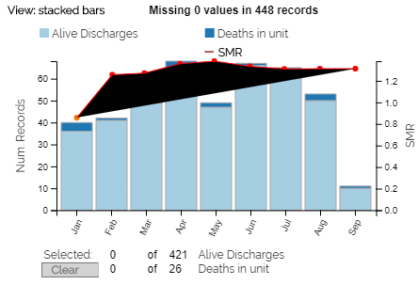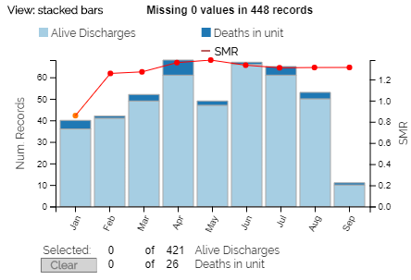

* Help and documentation can now be accessed via a new tab in QualDash:

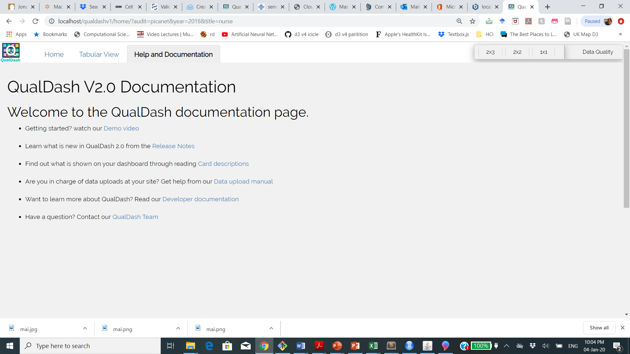

### Picanet-specific

* The calculation of SMR is no longer hard-coded in the QualDash software. SMR is now calculated using a trusted R package which is included in the R script for Picanet (this allows us to also include confidence intervals if needed but they are currently not included).
* Deaths are shown in the months in which they occurred. This is done by removing the admissions information from this card and keeping only the number of alive discharges and deaths in each month. This design decision was made after a few rounds of discussion with members of the Picanet team.
* The SMR curve is color-coded as a gradient (everything >= 1.0 is shown in red)
* The quantities sub-view now supports values that are extremely small. The example shown in the figure shows the average of PIM3 in each month which. We round small numbers up to the third decimal position.

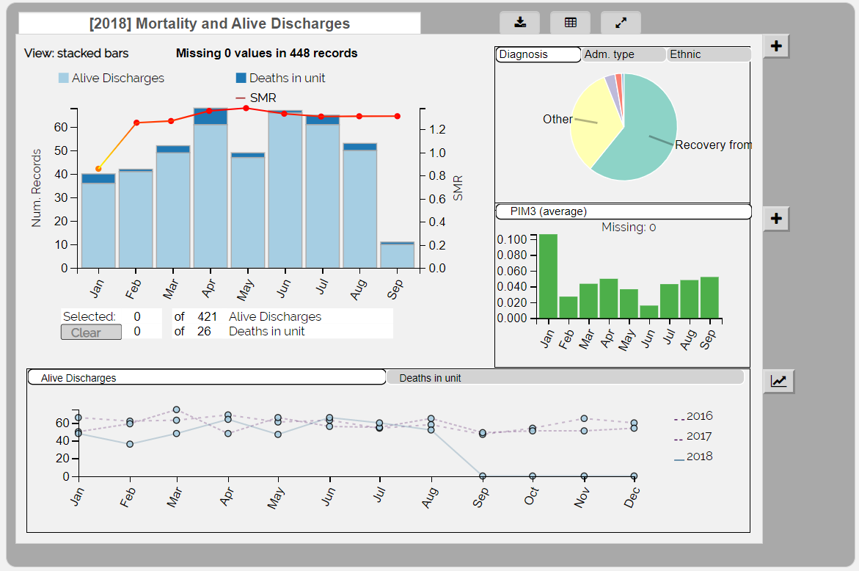

### MINAP-specific

* Financial year data can now be displayed by selecting the corresponding time frame from the QualDash start page.

